**WEEK-2 CTS-MODULE**

**PL/SQL**

**Exercise 1  
Control Structures**

Before running a Scenario I created tables:

CREATE TABLE Customers (

CustomerID NUMBER PRIMARY KEY,

Name VARCHAR2(100),

DOB DATE,

Balance NUMBER,

LastModified DATE

);

CREATE TABLE Loans (

LoanID NUMBER PRIMARY KEY,

CustomerID NUMBER,

LoanAmount NUMBER,

InterestRate NUMBER,

StartDate DATE,

EndDate DATE,

FOREIGN KEY (CustomerID) REFERENCES Customers(CustomerID)

);  
  
Inserting a values into tables:

-- Customers

INSERT INTO Customers VALUES (1, 'John Doe', TO_DATE('1960-05-15', 'YYYY-MM-DD'), 15000, SYSDATE);

INSERT INTO Customers VALUES (2, 'Jane Smith', TO_DATE('1990-07-20', 'YYYY-MM-DD'), 9000, SYSDATE);

-- Loans

INSERT INTO Loans VALUES (1, 1, 5000, 5.0, SYSDATE, ADD_MONTHS(SYSDATE, 60));

INSERT INTO Loans VALUES (2, 2, 7000, 6.5, SYSDATE, SYSDATE + 15);

COMMIT;

**Scenario 1:**

Discount a loan interest

BEGIN

FOR rec IN (

SELECT l.LoanID, c.DOB

FROM Customers c

JOIN Loans l ON c.CustomerID = l.CustomerID

) LOOP

IF MONTHS_BETWEEN(SYSDATE, rec.DOB) / 12 > 60 THEN

UPDATE Loans

SET InterestRate = InterestRate - 1

WHERE LoanID = rec.LoanID;

DBMS_OUTPUT.PUT_LINE(' Interest reduced for LoanID: ' || rec.LoanID);

END IF;

END LOOP;

COMMIT;

END;

**OUTPUT:**  
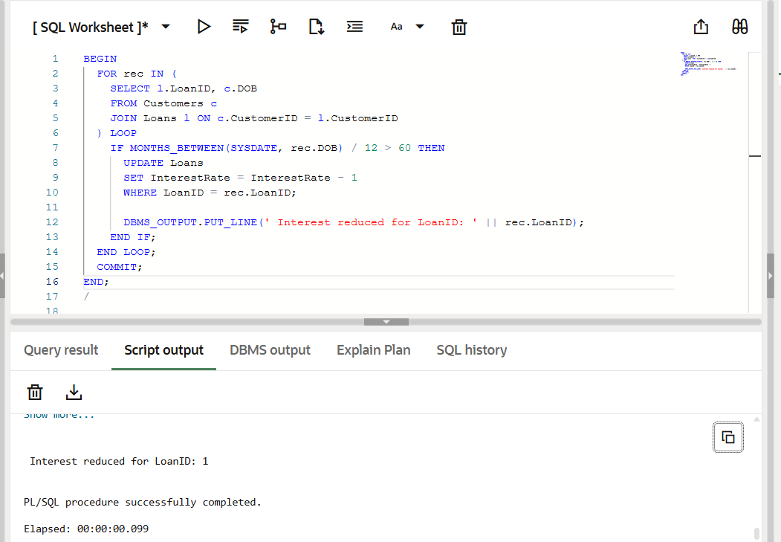

**Scenario 2:**  
  
customer an be promoted to VIP status

Before running a code ,alter the table using

ALTER TABLE Customers ADD IsVIP VARCHAR2(5);

BEGIN

  FOR rec IN (SELECT * FROM Customers) LOOP

    IF rec.Balance > 10000 THEN

      UPDATE Customers SET IsVIP = 'TRUE' WHERE CustomerID = rec.CustomerID;

      DBMS_OUTPUT.PUT_LINE('VIP marked for: ' || rec.Name);

    END IF;

  END LOOP;

  COMMIT;

END;

**OUTPUT:**  
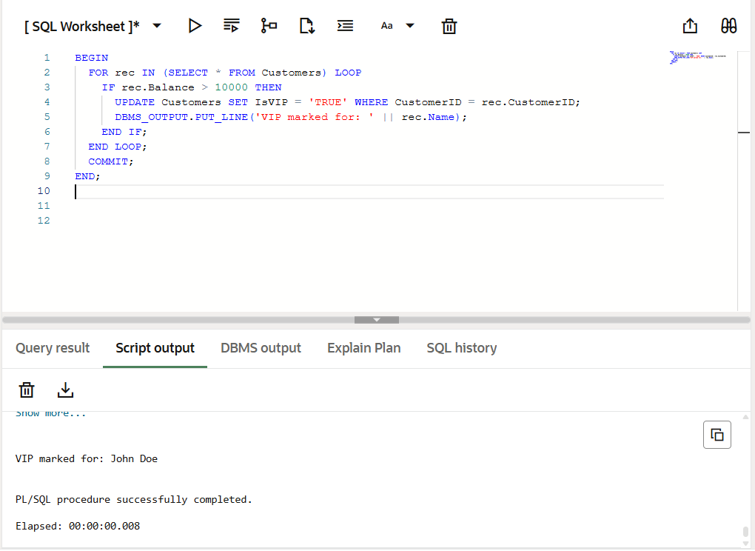  
  
**Scenario 3:**

Banks sends a reminder to customers  
  
BEGIN

FOR rec IN (

SELECT c.Name, l.EndDate

FROM Loans l

JOIN Customers c ON l.CustomerID = c.CustomerID

WHERE l.EndDate BETWEEN SYSDATE AND SYSDATE + 30

) LOOP

DBMS_OUTPUT.PUT_LINE(‘ Reminder: ' || rec.Name || '''s loan due on ' || TO_CHAR(rec.EndDate, 'DD-Mon-YYYY'));

END LOOP;

END;

**OUTPUT:**  
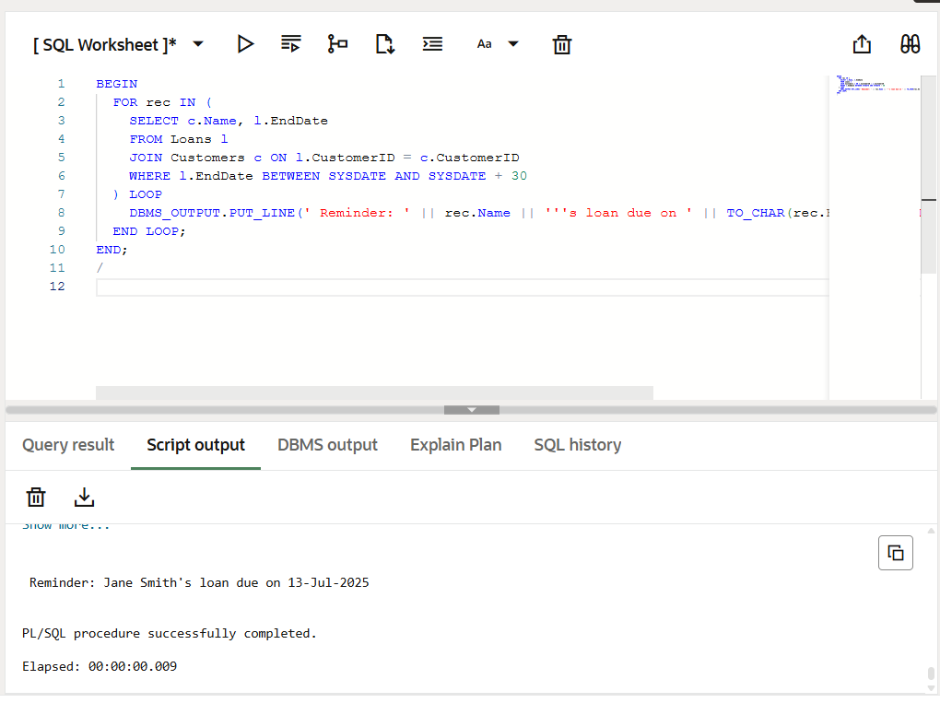

**Exercise 3:**

**Stored Procedures**

Creating a tables:

-- Accounts table

CREATE TABLE Accounts (

AccountID NUMBER PRIMARY KEY,

CustomerID NUMBER,

AccountType VARCHAR2(20),

Balance NUMBER,

LastModified DATE

);

-- Employees table

CREATE TABLE Employees (

EmployeeID NUMBER PRIMARY KEY,

Name VARCHAR2(100),

Position VARCHAR2(50),

Salary NUMBER,

Department VARCHAR2(50),

HireDate DATE

);  
  
Inserting a data:  
  
-- Sample Accounts

INSERT INTO Accounts VALUES (101, 1, 'Savings', 10000, SYSDATE);

INSERT INTO Accounts VALUES (102, 2, 'Current', 7000, SYSDATE);

-- Sample Employees

INSERT INTO Employees VALUES (201, 'Asha', 'Developer', 50000, 'IT', SYSDATE);

INSERT INTO Employees VALUES (202, 'Ravi', 'Tester', 40000, 'QA', SYSDATE);

COMMIT;  
  
**Scenario 1:**  
**Monthly Interest for savings account**:  
  
1.Creating a Stored procedure:

CREATE OR REPLACE PROCEDURE CalculateMonthlyInterest IS

BEGIN

FOR acc IN (SELECT AccountID, Balance FROM Accounts WHERE AccountType = 'Savings') LOOP

UPDATE Accounts

SET Balance = Balance + (acc.Balance * 0.01),

LastModified = SYSDATE

WHERE AccountID = acc.AccountID;

DBMS_OUTPUT.PUT_LINE(' Interest added for AccountID: ' || acc.AccountID);

END LOOP;

COMMIT;

END;

2.Execute a procedure:

BEGIN

CalculateMonthlyInterest;

END;

**Output:**

Interest added for AccountID: 101

3.View Balance :

SELECT * FROM Accounts;

**OUTPUT:**

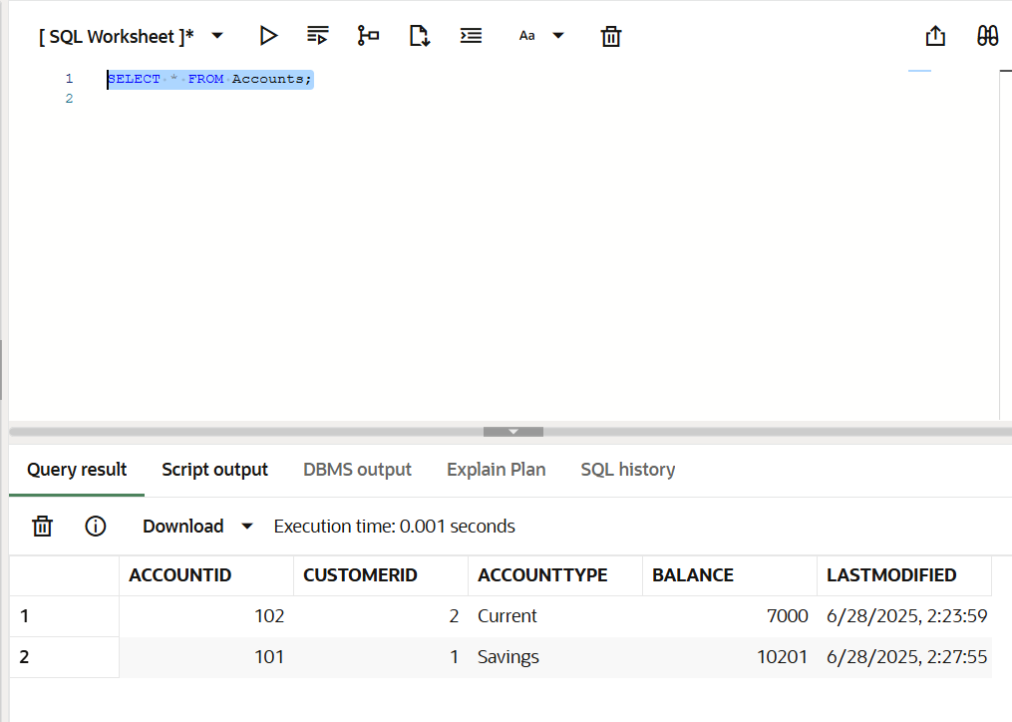

**Scenario 2:  
Employee Bonus By department**  
  
1.Creating a Stroed procedure:

CREATE OR REPLACE PROCEDURE GiveBonusToDepartment (

p_dept IN VARCHAR2,

p_bonus_pct IN NUMBER

) IS

BEGIN

UPDATE Employees

SET Salary = Salary + (Salary * p_bonus_pct / 100),

HireDate = SYSDATE -- Just for update tracking

WHERE Department = p_dept;

DBMS_OUTPUT.PUT_LINE('Bonus applied to department: ' || p_dept);

COMMIT;

END;

**Output:**  
Procedure GIVEBONUSTODEPARTMENT compiled  
  
2.Executing a procedure:  
  
BEGIN

GiveBonusToDepartment('IT', 10);

END;

**Output:**  
  
Bonus applied to department: IT

3.View the Updated details:

Updated Employees list:  
SELECT * FROM Employees;  
  
**OUTPUT:**  
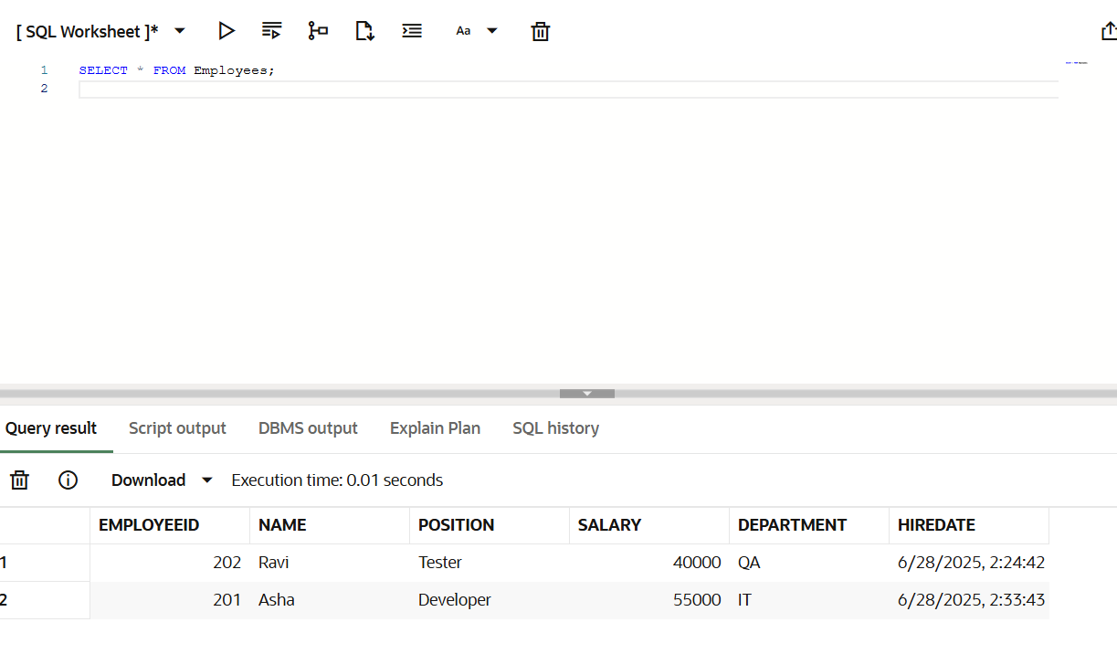

**Scenario 3:  
Transfer funds Between account safely**  
  
1.Creating a Stored Procedure:

CREATE OR REPLACE PROCEDURE TransferFunds (

p_from_account IN NUMBER,

p_to_account IN NUMBER,

p_amount IN NUMBER

) IS

v_balance NUMBER;

BEGIN

-- Check available balance

SELECT Balance INTO v_balance

FROM Accounts

WHERE AccountID = p_from_account;

IF v_balance < p_amount THEN

RAISE_APPLICATION_ERROR(-20001, ' Insufficient balance in source account');

ELSE

-- Debit from source

UPDATE Accounts

SET Balance = Balance - p_amount,

LastModified = SYSDATE

WHERE AccountID = p_from_account;

-- Credit to destination

UPDATE Accounts

SET Balance = Balance + p_amount,

LastModified = SYSDATE

WHERE AccountID = p_to_account;

COMMIT;

DBMS_OUTPUT.PUT_LINE(' Transferred ' || p_amount || ' from Account ' || p_from_account || ' to Account ' || p_to_account);

END IF;

END;

**OUTPUT:**  
  
Procedure TRANSFERFUNDS compiled  
  
2.Executing a Procedure:

BEGIN

TransferFunds(101, 102, 2000);

END;

**OUTPUT:**  
  
Transferred 2000 from Account 101 to Account 102  
  
3.Verify Balances:  
  
SELECT * FROM Accounts;  
  
**OUTPUT:**